CHEMISTRY

SEMESTER ONE EXAMINATION
ANSWERS

PART 1

1. (c) | 6. (b) | 11. (c) | 16. (a)
2. (a) | 7. (d) | 12. (d) | 17. (c)
3. (a) | 8. (c) | 13. (c) | 18. (b)
4. (c) | 9. (b) | 14. (a) | 19. (a)
5. (d) | 10. (c) | 15. (c) | 20. (b)

PART 2

(a) Equation: Cr₂O₃(s) + 6H⁺(aq) → 2Cr³⁺(aq) + 3H₂O()

Observation: Green solid dissolves to produce a deep green solution.

(b) Equation: 3Ni²⁺(aq) + 2PO₄³⁻(aq) → Ni₃(PO₄)₂ (s)

Observation: A bright green solution and a colourless solution produces a green precipitate.

(c) Equation: Ca(OH)₂(s) + 4NH₃(aq) → [Cu(NH₃)₄]²⁺(aq) + 2OH⁻(aq)

Observation: Pale blue solid dissolves to produce a deep blue solution.

(d) Equation: 2CrO₄²⁻(aq) + 2H⁺(aq)  Cr₂O₇²⁻ (aq) + H₂O()

Observation: A yellow solution changes to an orange coloured solution

2.
Species | Structural formula  (showing all valence electrons) | Sketch and name the shape
EXAMPLE:  Water  (H₂O) | 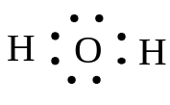 | 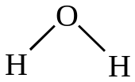  Name of shape Bent
Arsine  (AsH₃) | 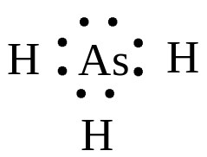 | 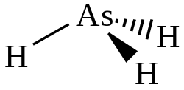  Name of shape Pyramidal
Nitrite ion  (NO₂⁻) | 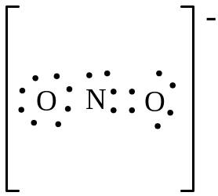 | 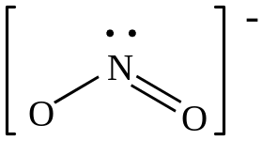  Name of shape Bent or V-Shaped
Germane  (GeH₄) | 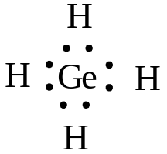 | 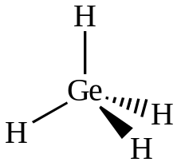  Name of shape Tetrahedral
.
3.
δ+
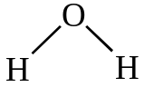
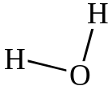
δ−
δ+
δ+
δ+
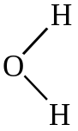
δ−
δ+
δ+
δ+
δ−
δ−
I ⁻
K⁺
and

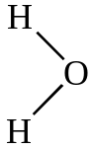
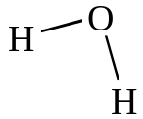
δ+
δ+
δ+
δ+
δ−

δ+

4.
Substances | Chemical Test | Observations
Solid zinc nitrate  and  Solid magnesium nitrate | 1. Add OH⁻ or NH₃ solution.  OR  2. Add water to each then add OH⁻ or NH₃ solution gradually until in excess | For zinc nitrate  1. Dissolves to form a colourless solution.  2. White precipitate forms which dissolves to form a colourless solution
Solid zinc nitrate  and  Solid magnesium nitrate |  | For magnesium nitrate  1. Does not dissolve.  2. White precipitate forms which does not dissolve.

5.
Compound | Electrical conductivity | Explanation
HC(aq) | High | Ionisation of HC to H⁺ and C⁻ is complete  HC(aq)  H⁺(aq) + C⁻(aq)  [H⁺] = [C⁻] = [HC] = 0.100 mol L⁻¹  High ion concentration, therefore high conductivity
NH₃(aq) | Low | Ionisation of NH₃ to NH₄⁺ and OH ⁻ is very small  NH₃(aq) + H₂O()  NH₄⁺(aq) + OH ⁻(aq)  [NH₄⁺] = [OH ⁻] <<< [NH₃] <<< 0.100 mol L⁻¹  Low ion concentration, therefore low conductivity
NH₄C(aq) | High | Dissociation of NH₄C to NH₄⁺ and C⁻ is complete  NH₄C(s)  NH₄⁺(aq) + C⁻(aq)  [NH₄⁺] = [C⁻] = [NH₄⁺C] = 0.100 mol L⁻¹  High ion concentration, therefore high conductivity

6 (a) To predict changes to the concentration of reactants and products that occur when a change is made to a system in chemical equilibrium.

(b) (i) Increased
(ii) Increased
(iii) unchanged

(c) (i) Decreased
(ii) Increased
(iii) No change

(d) 1. Increase the rate of the forward reaction with no immediate increase in the rate of the reverse reaction.
2. As the concentration of the SO₃ increases the rate of the reverse reaction begins to increase.
3. As the concentration of reactants decreases the rate of the forward reaction decreases.

PART 3

1. (a) HC(aq) + Ag⁺(aq)  H⁺(aq) + AgC (s) [M(AgC = 143.35 g mol⁻¹]

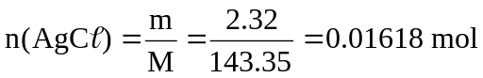
N(HC) = n(AgC) = 0.01618 mol
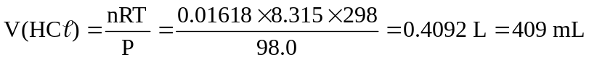

(b) n(Ag⁺)_{initial} = n(AgNO₃) = cV = 0.200 × 0.250 = 0.0500 mol
n(Ag⁺)_{ppt} = n(AgC) = 0.01618 mol
n(Ag⁺)_{left} = n(Ag⁺)_{initial} − n(Ag⁺)_{ppt} = 0.0500 − 0.01618 = 0.03382 mol
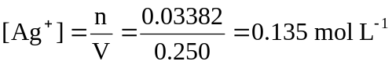

(c) C₆H₆C₆ + 12O₂  6CO₂ + 6HC
n(C₆H₆C₆) = 1/6n(HC) = 1/6(0.01618) = 2.6967 × 10⁻³ mol
[M(C₆H₆C₆) = 290.808 g mol⁻¹]
m(C₆H₆C₆) = nM = 2.6967 × 10⁻³ × 290.808 = 0.7842 g
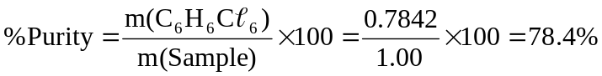

2. CuCO₃(aq) + 2H⁺(aq)  Cu²⁺(aq) + CO₂ (s) + H₂O()
And H⁺(aq) + OH ⁻(aq)  H₂O()
n(H⁺)_{initial} = 2n(H₂SO₄) = 2cV = 2 × 1.250 × 0.0250 = 0.0625 mol
n(H⁺)_{left} = n(OH ⁻) = n(NaOH) = cV = 0.250 × 0.0176 = 4.40 × 10⁻³ mol
n(H⁺)_{used} = n(H⁺)_{initial} − n(H⁺)_{left} = 0.0625 − 4.40 × 10⁻³ mol
n(Cu) = n(CuCO₃) = ½ n(H⁺)_{used} = ½ × 0.0581 = 0.02905 mol
n(Cu)_{in 5.00 g} = nM = 0.02905 × 63.55 = 1.846 g

3. 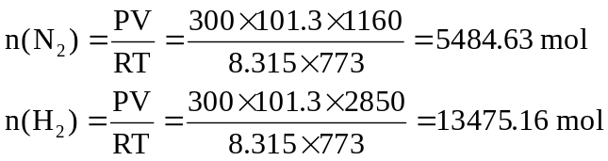
n(H₂)_{required to use all nitrogen} = 3n(N₂) = 3 × 5484.63 = 16453.89 mol
There is only 13475.16 mol of hydrogen so H₂ is the limiting reagent.
From the equations:
n(HNO₃) = ⅔ n(H₂) = ⅔ 13475.16 = 8983.44 mol
[M(HNO₃) = 63.018 g mol⁻¹]
m(HNO₃) = nM = 8983.44 × 63.018 = 566118 g = 5.66 ×10⁵ g = 566 kg

For answers to Part 4 please see the Extended Answer Question Answers

